 

Model Development Phase Template

|  |  |
| --- | --- |
| Date | 20 july 2024 |
| Team ID | 739716 |
| Project Title | Predicting Baseline Histological staging in HCV patients using ML |
| Maximum Marks | 10 Marks |

# Initial Model Training Code, Model Validation and Evaluation Report

The initial model training code will be showcased in the future through a screenshot. The model validation and evaluation report will include a summary and training and validation performance metrics for multiple models, presented through respective screenshots.

# Initial Model Training Code (5 marks):

**Model Validation and Evaluation Report (5 marks):**

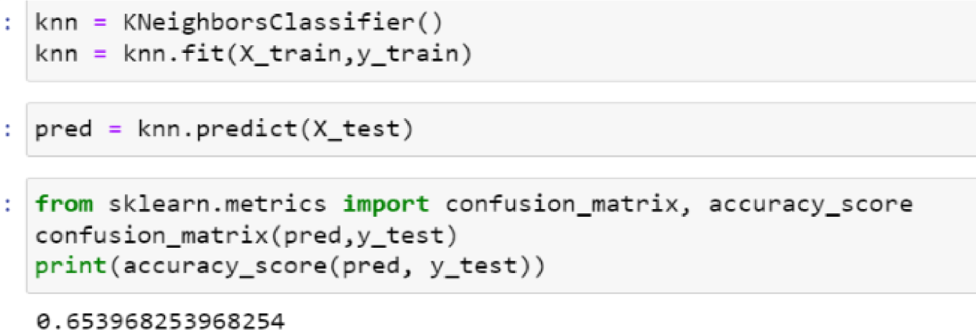

machine

|  |
| --- |
| **Model Summary**  Knn The K  model Nearest  Neighbors Classifier |
| (KNN) is a versatile and simple |
| learning algorithm used for  both |
| classification and  regression tasks. It operates on the principle of proximity, |
| labels to data points based on  the majority class among their k- nearest  neighbors. KNN is non- parametric and requires no training phase,  making it particularly suitable for applications |

assigning

# Training and Validation Performance Metrics

where data relationships are not well- defined or change dynamically.

Decision tree model

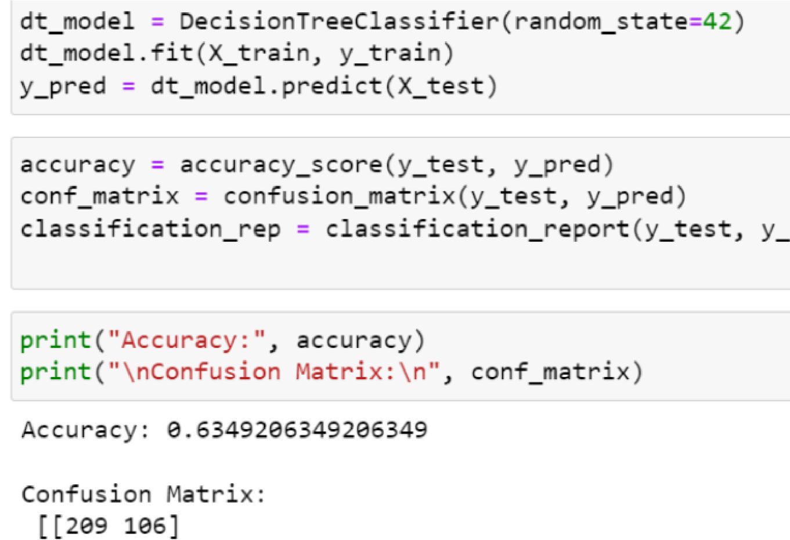

The decision tree

classifier is apopular machine learning algorithm used for both

classification and

regression tasks

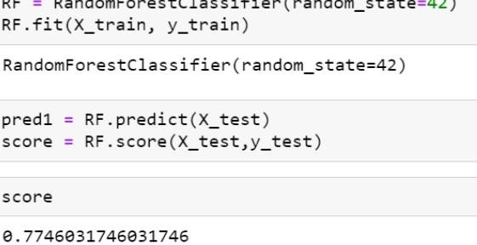

It is widely used for its ablity to handle complex data

sets,and resistance to overfitting

Random forest

classifier